AZURE CLI

#### Task 1: Create a resource group and an Azure managed disk by using Azure CLI

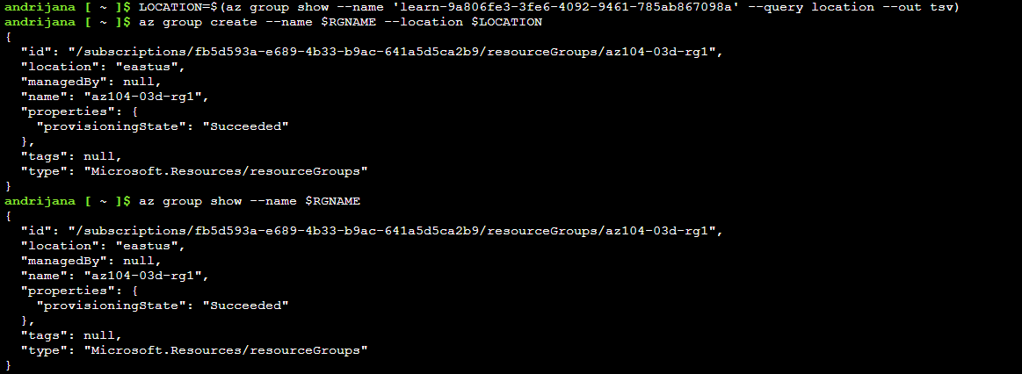



I used the previous resource group I had from the DevTestLab (where we created the virtual machines on Azure – and we were told that we should at least stop them if we don’t delete them)

**Task2:** Create a new Disk

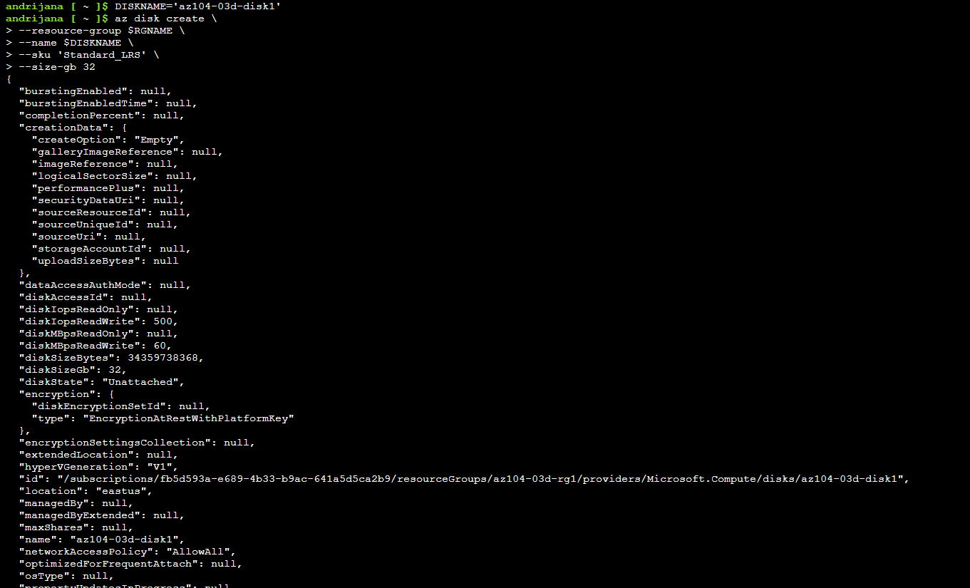

**Task3:** Retrieve information from the newly-created Disk

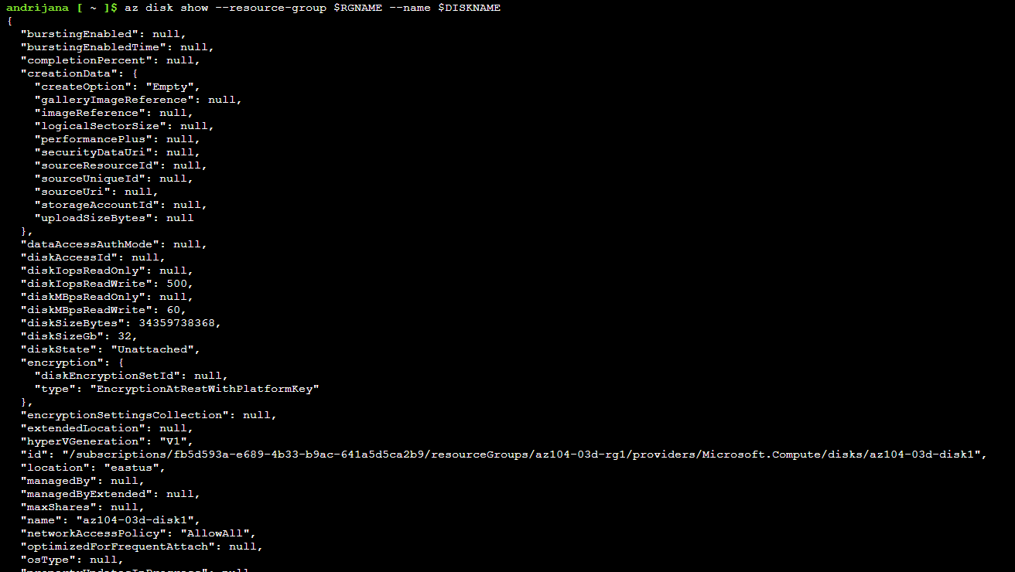

**Task 4:** Configure the managed disk by using Azure CLI

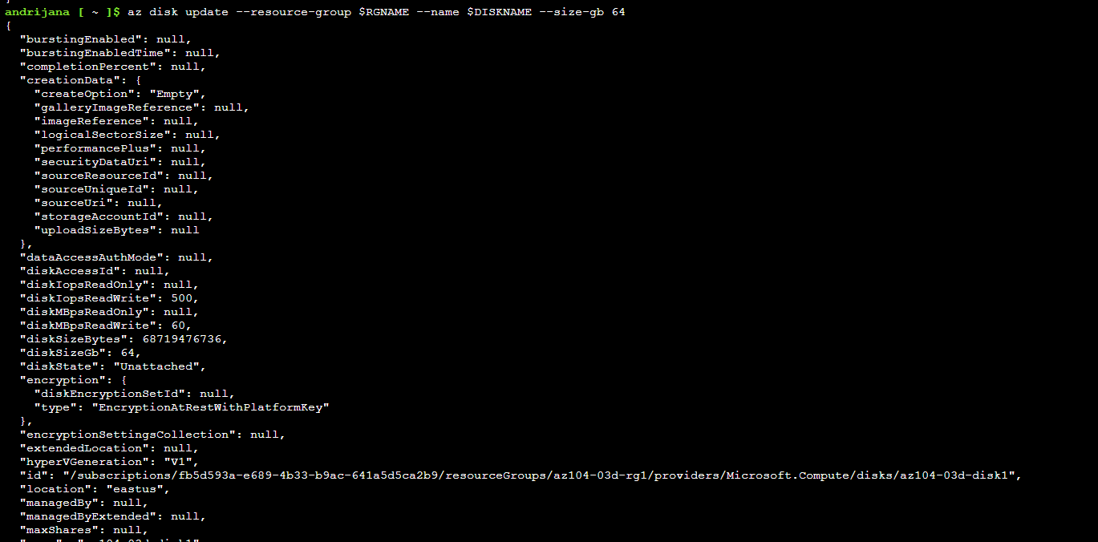

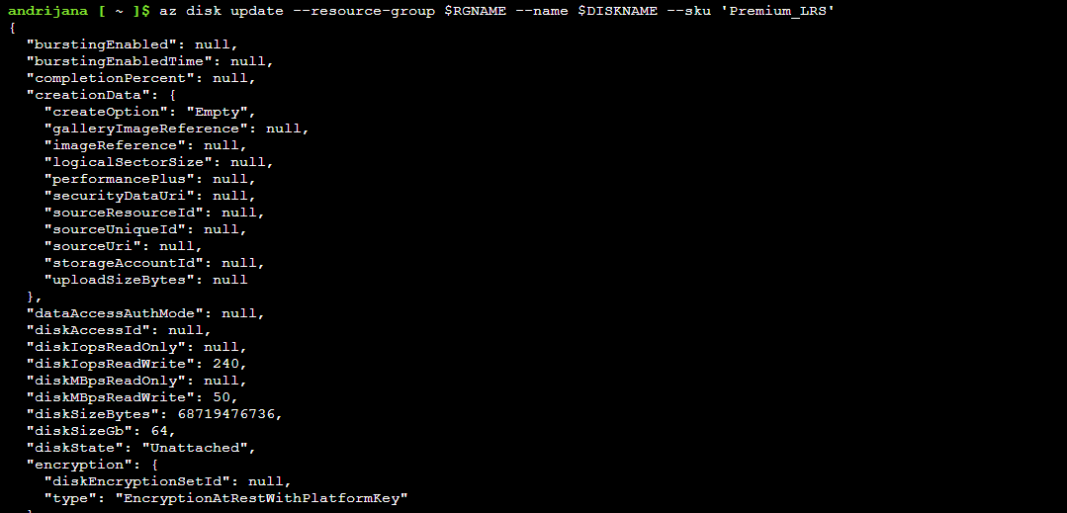

**Task5:** To change the disk performance SKU to **Premium_LRS**



**Task6:** To verify that the change took effect

